MEC1040 Engine Fundamentals

Manual

*Do not make any marks in this book.*

This book is designed to be used as a resource for the independent study course MEC1040 being offered by Prairie Land Regional Division

***Introduction***

This module is designed to introduce students to the fundamentals of gas engines, safety, tools and small engine mechanics. This manual is the main resource for the workbook, but access to a computer is needed to view some video clips as indicated throughout the module.

Students will be dismantling a single cylinder engine as part of this course. The engines and necessary tools will be provided in the student work station, but some tools are also available from the teacher work station. It is important that all tools and equipment is returned to the proper location when done with.

The engines used in this program are non-running engines, but they may still have some fluids in them. Also, various solvents and lubricants may be used throughout the course, so students must be aware of proper handling and disposal procedures.

***CARBON MONOXIDE***

Carbon monoxide is a chemical compound of carbon and oxygen with the formula CO. It is a colorless, odorless gas, about 3 percent lighter than air, and is poisonous to all warm-blooded animals and many other forms of life. When inhaled it combines with hemoglobin in the blood, preventing absorption of oxygen and resulting in asphyxiation.

Carbon monoxide is formed whenever carbon or substances containing carbon are burned with an insufficient air supply. Even when the amount of air is theoretically sufficient, the reaction is not always complete, so that the combustion gases contain some free oxygen and some carbon monoxide.

An incomplete reaction is especially probable when it takes place quickly, as in an automobile engine; for this reason, automobile-exhaust gases contain harmful quantities of carbon monoxide, sometimes several percent, although antipollution devices are intended to keep the level below 1 percent. As little as 1/1000 of 1 percent of carbon monoxide in air may produce symptoms of poisoning and as little as 1/5 of 1 percent may prove fatal in less than 30 min. Carbon monoxide is a major ingredient of the air pollution in urban areas.

Because it is odorless, carbon monoxide is an insidious poison. It produces only mild symptoms of headache, nausea, or fatigue, followed by unconsciousness. An automobile engine running in a closed garage can make the air noxious within a few minutes; a leaking furnace flue may fill a house with unsuspected poison. Fuel gas, which may contain as much as 50 percent carbon monoxide, often has small quantities of unpleasant-smelling sulfur compounds purposely added to make leaks noticeable.

Carbon monoxide is an important industrial fuel because it contains more than two-thirds of the heating value of the carbon from which it was formed. It is a constituent of water gas, producer gas, blast furnace gas, and coal gas. In smelting iron ore carbon monoxide formed from coke used in the process acts as a reducing agent, that is, it removes oxygen from the ore. Carbon monoxide combines actively with chlorine to form carbonyl chloride, or phosgene, and it combines with hydrogen, when heated in the presence of a catalyst, to form methyl alcohol. The direct combination of carbon monoxide with certain metals, forming gaseous compounds, is used in refining those metals, particularly nickel.

Carbon monoxide melts at -205° C (-337° F) and boils at -191.5° C (-312.7° F).

Carbon Monoxide. Funk & Wagnalls. 2011.  
Discovery Education. 3 August 2011  
<http://streaming.discoveryeducation.com/>

***Gasoline***

This fact sheet provides answers to questions about gasoline. It will explain what gasoline is, how you can be exposed to it, how it can make you sick, and ways to reduce or prevent your exposure to gasoline.

What is gasoline?

Gasoline is made from processed crude oil and is a pale brown or pink liquid with a strong odor. It evaporates easily, is very flammable and can form explosive mixtures in air. Typical gasoline contains about 150 different chemicals, including benzene, toluene, ethylbenzene and xylene, which also are known as the BTEX compounds.

Gasoline also contains chemicals such as lubricants, anti-rust agents and anti-icing agents that are added to improve car performance. These chemicals usually are only present in very small amounts. Before the 1980s, lead was commonly used in gasoline as an anti-knocking agent. The use of lead has been stopped due to air pollution and the possibility of adverse health effects. Some gasolines also contain ethanol, which is made from corn. Ethanol helps a car run more efficiently and it produces less pollution. The most common additive used in gasoline is methyl tertiary-butyl ether (MTBE). It is added to increase octane and oxygen levels and reduce pollution emissions.

How does gasoline get into the environment?

Spills, leaks or improper disposal of gasoline can cause contamination of soil, groundwater, surface water and air. Leaking underground storage tanks or pipelines also can cause gasoline to enter surrounding soil and groundwater. Gasoline can be released into the air when large tanker trucks are filled and emptied and when you fill your car at the service station.

You can be exposed to gasoline by:

* breathing gasoline vapors,
* drinking water contaminated with gasoline, or
* touching gasoline or soil or water contaminated with gasoline.

The most common exposure to gasoline occurs by breathing vapors when filling your car’s fuel tank. Vapors also can be present in air when gasoline evaporates out of contaminated soil or water. Gasoline vapors can build up in basements, crawlspaces and living areas.

When gasoline seeps into soil, it can contaminate groundwater used for drinking. Most chemicals in gasoline are removed during water treatment, but people who drink untreated water or water from private wells can be exposed. Gasoline also can be absorbed through skin during contact, such as when pumping gas or cleaning up a gasoline spill.

Health Effects of Gasoline Exposure

Many adverse health effects of gasoline are due to individual chemicals in gasoline, mainly BTEX, that are present in small amounts. Breathing small amounts of gasoline vapors can lead to nose and throat irritation, headaches, dizziness, nausea, vomiting, confusion and breathing difficulties. Symptoms from swallowing small amounts of gasoline include mouth, throat and stomach irritation, nausea, vomiting, dizziness and headaches. Some effects of skin contact with gasoline include rashes, redness and swelling. Being exposed to large amounts of gasoline can lead to coma or death.

The health effects of being exposed to gasoline over long periods of time are not well known. This is because people exposed to gasoline are usually exposed to many other things that also can cause health effects. Some workers who are exposed to gasoline every day in their jobs have suffered memory loss and decreased muscle function. At very high levels, some of the chemicals in gasoline, such as benzene, are known to cause cancer. Current evidence, however, does not show that exposure to low levels of gasoline causes cancer in humans.

Can I be tested for gasoline exposure?

There are laboratory blood or urine tests that can determine if you have been exposed to gasoline, but these tests are not generally available in your doctor’s office. These tests measure BTEX compounds in your body, which may be present as a result of exposure to sources other than gasoline.

How can I reduce my exposure to gasoline?

Due to the widespread use of gasoline in cars, trucks, buses and lawn care equipment, eliminating exposure would be difficult. Typically, you can smell gasoline at levels that would not be expected to cause adverse health effects. Since gasoline can be smelled at low levels, the source can usually be found and eliminated.

If you suspect that your water supply is contaminated with gasoline, here are a few ways to reduce your exposure:

If gasoline is in your well water, do not drink it. Consider using bottled water for drinking and cooking, using a water treatment unit certified to remove gasoline chemicals, or connecting to a public water supply.

Shower or wash in cooler water. Wash and rinse clothes in cold water. The hotter the water, the more gasoline evaporates into the air you breathe.

Air out bathrooms, washrooms and kitchens during and after water use by opening doors and windows and turning on exhaust fans.

|  |
| --- |
| ***Gasoline Safety***  If you must have gasoline around the house:  **Always** store it in approved safety containers - these can be expensive, but it is cheap "fire insurance"  **Always** have a fire extinguisher marked for "B" type fires (Gasoline and other flammable liquids) - Be sure you know how to use it!  **Always** keep the minimum amount of gas required  **Always** store the container in a cool and well ventilated area. Keep it away from any source of heat or sparks such as water heater, electric motor or car engines  **Always** store the containers in the garage or shed rather than the house  **Never** carry gasoline in the trunk of your car  **Always** keep gasoline away from children  **Never** siphon gasoline by sucking the hose; gasoline can be fatal to adults as well if swallowed  **Never** use gasoline as a cleaner, a charcoal starter or a solvent  If you or your child should ever swallow gasoline, then  **Move** the child away from the gasoline source; then secure the gasoline safely  Call your doctor or Poison Centre immediately, or call 911  **Never** induce vomiting; the same is true kerosene, lighter fluid and fuel oil  For gasoline on clothing - remove the clothing and dispose of carefully  For gasoline of skin - use lots of warm soapy water to reduce the risk of chemical burns  If you do have a gasoline fire and don't have a "B" type fire extinguisher  Get everyone away from the fire  Call the Fire department by dialing 911  Stay calm  **Never** use water to put out a gasoline fire |

|  |  |  |  |  |  |  |  |  |  |  |  |  |  |  |  |  |
| --- | --- | --- | --- | --- | --- | --- | --- | --- | --- | --- | --- | --- | --- | --- | --- | --- |
| ***Classes of Fires***  You must understand that fighting a fire is serious business. Even a small fire can quickly spread to engulf an entire room...or worse. Don't think about trying to use a fire extinguisher unless you have, at the very least, read the information on this page and know what you are doing.  Types of Fires and Extinguishers  The National Fire Protection Association (NFPA) categorizes fires by class. Extinguishers are marked accordingly and you should always be sure to use the appropriate kind of extinguisher for that type of fire.   | Class | Type | Description | | --- | --- | --- | | Class A | Trash, Wood, Paper | Class A fires involve ordinary combustible materials--paper, wood, fabrics, rubber, and many plastics. Quenching by water or insulating by a multipurpose (ABC) dry chemical agent is effective. | | Class B | Liquids, Grease | Class B fires occur in flammable liquids--gasoline, oils, greases, tars, paints, lacquers, and flammable gases. Dry chemicals and carbon dioxide agents extinguish these fires. | | Class C | Electrical Equipment | Class C fires take place in live electrical equipment--motors, generators, switches, and appliances. Non-conducting extinguishing agents such as dry chemicals or carbon dioxide are required to extinguish them. *Never use a Class A (water) extinguisher on this type of fire!* | | Class D | Combustible Metals | Class D fires occur in combustible metals such as magnesium, titanium, zirconium, sodium, lithium, and potassium. Sodium carbonate, graphite, bicarbonate, sodium chloride, and salt-based chemicals extinguish these fires. |   **A Word of Caution:** Some fires may be a combination of these!  ***The Basics of Using a Fire Extinguisher***  You are not required to fight a fire. Ever. If you have the slightest doubt about your control of the situation, **DO NOT FIGHT THE FIRE.**  Use a mental checklist to make a Fight-or-Flight Decision. Attempt to use an extinguisher only if ALL of the following apply:  The building is being evacuated (fire alarm is pulled)  The fire department is being called (dial 911).  The fire is small, contained and not spreading beyond its starting point.  The exit is clear, there is no imminent peril and you can fight the fire with your back to the exit.  You can stay low and avoid smoke.  The proper extinguisher is immediately at hand.  You have read the instructions and know how to use the extinguisher.  ***If any of these above conditions have not been met, don't fight the fire yourself.***  If you decide to use an extinguisher, whenever possible, use the "Buddy System". Have someone back you up when using a fire extinguisher. If you have any doubt about your personal safety, or if you cannot extinguish a fire, leave immediately and close off the area (close the doors, but DO NOT lock them). Leave the building but contact a firefighter to relay whatever information you have about the fire.  Pull the pin on the fire extinguisher.  Stand several feet from the fire, depress the handle and sweep back and forth towards the base of the fire.  Do not walk on an area that you have "extinguished" in case the fire reignites or the extinguisher runs out! Remember: you usually can't expect more than 10 full seconds of extinguishing power on a typical unit and this could be significantly less if the extinguisher was not properly maintained or partially discharged.  The metal parts of CO2 extinguishers tend to get dangerously cold -- practice using one beforehand or have someone show you the proper way to hold one.  Direct the extinguisher at the base of the flames until the fire is completely out.  Recharge any discharged extinguisher immediately after use. (Even if you discharge an extinguisher just a tiny bit) |  |

***An Introduction to Small Engines (watch the video clips “How Cars Work” and “Bill Nye Internal Combustion”)***

Four stroke (cycle) engine

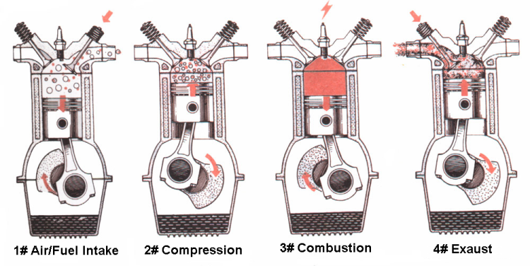

## STEP 1: INTAKE STROKE

This is the very first step in the chain of events that makes an engine run. This is also the most important step. Incorrectly metered fuel entering the combustion chamber (cylinder) can severely hamper performance (explained later in the carburetion theory). Valve clearance is also a very important factor.

During the Intake Stroke, the piston is traveling downwards toward BDC (Bottom Dead Center). At the very same time, the intake lobe on the cam shaft is pushing up on the valve tappet, which opens the valve. So at the very moment, the piston is traveling downward while the intake valve is opening. Now the piston is creating negative air pressure or vacuum. Naturally, we can't have negative air pressure, so a charge of gas and air comes rushing into the cylinder through the carburetor. By the time the piston arrives at BDC, the air pressure inside the cylinder is equal to the air pressure outside the engine.

Now, the piston is leaving the BDC position and the cam lobe is leaving the tappet, allowing the valve to close for the next step.

## STEP 2: COMPRESSION STROKE

How healthy your engine is how well the compression stroke works. For the engine to be very efficient, all of the "charge" (air and fuel mixture) must stay inside cylinder as long as possible. And for this to be possible, the rings, valves and cylinder must be in good shape to prevent the "charge" from leaking out.

The piston is now traveling back up the cylinder and the intake valve is closing. By the time the piston reaches TDC (Top Dead Center), it has squeezed, let’s say, 13 Cubic Inches of charge into less than 1. If your rings and cylinder were in bad shape, most of that charge would have leaked around the rings, reducing the compression ratio.

## STEP 3: COMBUSTION (POWER) STROKE

The Power Stroke is the most extreme stroke. It puts a great amount of pressure on the entire engine (rings, rod, crankshaft, valves and valve seats and piston.) This stroke does something with that charge that we squeezed from 13 to 1. While the piston was traveling towards TDC, CDI, or magneto, was building up a charge and at around 12 degrees or less BTDC (Before Top Dead Center), the charge is released and arcs across the spark plug. By the time the piston arrives at TDC, the charge is violently exploded inside the engine, pushing the piston downward (power).

You now ask yourself, how did the piston get violently pushed downwards? What happened was, the charge that we squeezed to 1 rapidly expanded back to 13. Obviously you can't cram 13 of anything into 1, so the expansion of the "charge" forces the piston downward, making useful power.

## STEP 4: EXHAUST STROKE

Now that we had the power stroke, our "charge" is now used up, so we need to get rid of it and start over. With the energy from power stroke, the piston reaches BDC and explained above and begins to travel upwards. While the piston is traveling upwards, the exhaust lobe on the cam gear comes in contact with the exhaust tappet, opening the exhaust valve. The exhaust is pushed out of the cylinder as the piston travels upward. By the time the piston reaches TDC, the exhaust valve closes and intake valve opens again, and the cycle is started over.

Now with that said, you may wonder, "If there is only one power stroke for every 4 total strokes, then what makes the engine continue going without stopping, because I know that there is not enough energy created to run the engine for three more strokes before making another power stroke?"

And that is a great question you asked yourself. What helps the engine continue through the other 3 "useless" strokes is inertia. And that inertia can be found in the flywheel. That extra 15 pounds of weight on the crankshaft "pushes" the engine through the other 3 strokes. And we call that Momentum.

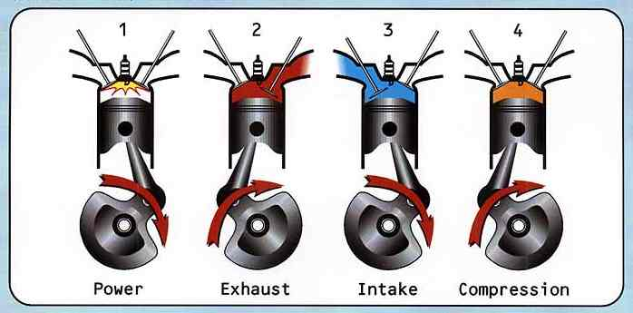

***How Two-stroke Engines Work***

Two-stroke Basics

This is what a two-stroke engine looks like:

|  |
| --- |
| http://static.howstuffworks.com/gif/two-stroke-parts.gif |

You find two-stroke engines in such devices as [chain saws](http://www.howstuffworks.com/chainsaw.htm) and jet skis because two-stroke engines have three important advantages over four-stroke engines:

Two-stroke engines do not have valves, which simplifies their construction and lowers their weight.

Two-stroke engines fire once every revolution, while four-stroke engines fire once every other revolution. This gives two-stroke engines a significant power boost.

Two-stroke engines can work in any orientation, which can be important in something like a chainsaw. A standard four-stroke engine may have problems with oil flow unless it is upright, and solving this problem can add complexity to the engine. These advantages make two-stroke engines lighter, simpler and less expensive to manufacture. Two-stroke engines also have the potential to pack about twice the power into the same space because there are twice as many power strokes per revolution. The combination of light weight and twice the power gives two-stroke engines a great **power-to-weight ratio** compared to many four-stroke engine designs.

The figure below shows a typical **cross flow** design

You can understand a two-stroke engine by watching each part of the cycle. Start with the point where the **spark plug** fires. Fuel and air in the cylinder have been compressed, and when the spark plug fires the mixture ignites. The resulting **explosion** drives the **piston** downward. Note that as the piston moves downward, it is compressing the air/fuel mixture in the crankcase. As the piston approaches the bottom of its stroke, the **exhaust port** is uncovered. The **pressure** in the cylinder drives most of the exhaust gases out of cylinder, as shown here:

|  |
| --- |
| http://static.howstuffworks.com/gif/two-stroke-exhaust.gif |

Fuel Intake

As the piston finally bottoms out, the **intake port** is uncovered. The piston's movement has **pressurized** the mixture in the crankcase, so it rushes into the cylinder, **displacing** the remaining exhaust gases and filling the cylinder with a fresh charge of fuel.

|  |
| --- |
| http://static.howstuffworks.com/gif/two-stroke-intake.gif |

Note that in many two-stroke engines that use a cross-flow design, the piston is shaped so that the incoming fuel mixture doesn't simply flow right over the top of the piston and out the exhaust port.

The Compression Stroke

Now the momentum in the crankshaft starts driving the piston back toward the spark plug for the **compression stroke**. As the air/fuel mixture in the piston is compressed, a **vacuum** is created in the crankcase. This vacuum opens the **reed valve** and sucks air/fuel/oil in from the **carburetor**.

Once the piston makes it to the end of the compression stroke, the spark plug fires again to repeat the cycle. It's called a two-stroke engine because there is a **compression stroke** and then a **combustion stroke**. In a four-stroke engine, there are separate intake, compression, combustion and exhaust strokes.

You can see that the piston is really doing three different things in a two-stroke engine:

On one side of the piston is the **combustion chamber**, where the piston is compressing the air/fuel mixture and capturing the energy released by the ignition of the fuel.

On the other side of the piston is the **crankcase**, where the piston is creating a vacuum to suck in air/fuel from the carburetor through the reed valve and then pressurizing the crankcase so that air/fuel is forced into the combustion chamber.

Meanwhile, the sides of the piston are acting like **valves**, covering and uncovering the intake and exhaust ports drilled into the side of the cylinder wall.

***Disadvantages of the Two-stroke***

You can now see that two-stroke engines have two important advantages over four-stroke engines: They are simpler and lighter, and they produce about twice as much power. So why do cars and trucks use [four-stroke engines](http://www.howstuffworks.com/engine.htm)? There are four main reasons:

Two-stroke engines don't last nearly as long as four-stroke engines. The lack of a dedicated lubrication system means that the parts of a two-stroke engine wear a lot faster.

Two-stroke oil is expensive, and you need about 4 ounces of it per gallon of [gas](http://www.howstuffworks.com/gasoline.htm). You would burn about a gallon of oil every 1,000 miles if you used a two-stroke engine in a car.

Two-stroke engines do not use fuel efficiently, so you would get fewer miles per gallon.

Two-stroke engines produce a lot of pollution -- so much, in fact, that it is likely that you won't see them around too much longer.

The **pollution** comes from two sources. The first is the combustion of the oil. The oil makes all two-stroke engines smoky to some extent, and a badly worn two-stroke engine can emit huge clouds of oily smoke. The second reason is less obvious but can be seen in the following figure:

|  |
| --- |
| http://static.howstuffworks.com/gif/two-stroke-compress.gif |

Each time a new charge of air/fuel is loaded into the combustion chamber, part of it **leaks out** through the exhaust port. That's why you see a sheen of oil around any two-stroke boat motor. The leaking hydrocarbons from the fresh fuel combined with the leaking oil are a real mess for the environment.

***Small Engine General Information***

Small engines are classified as either vertical or horizontal shaft types. A vertical shaft would be a typical lawnmower engine. A horizontal shaft would be a pump, roto-tiller or snowmobile.

Engines of all types have several systems in common. These systems vary in their design and operation, but they still accomplish the same outcome.

Fuel and Carburetion - This system provides the air/fuel mixture needed for the engine to operate. This includes the fuel tank, air filter, and carburetor.

Ignition – this system provides the spark for igniting the fuel, allowing the creation of power for making the engine run. Main parts of this system include magneto/flywheel, coil, points, wires and sparkplug.

Lubrication – the lubrication system controls friction between moving parts, provides a seal around moving parts and removes some of the engine’s heat. Parts of the lubrication system include oil, galleries, seals, and a pump or slinger.

Cooling – this system removes the majority of the heat from the engine. It includes a fan or blower to move the air and shrouds to direct the air.

Exhaust – the exhaust system removes the burnt gasses from the cylinder. It consists primarily of the muffler.

***Fastener Identification***

Every engine uses a variety of fasteners. All fasteners can be classed as either mechanical or chemical. Mechanical fasteners are those which join to each other by compression, threading or friction. Chemical fasteners use the chemical properties of materials to bond or hold pieces together. The majority of fasteners found on a small engine are mechanical. The only chemical fasteners which may be found tend to be gasket sealers and the occasional weld.

Nuts and bolts are the most common fastener on engines. In many cases, bolts aren’t attached to the engine using nuts, but are instead attached by being turned in to threaded holes on the block or part. Bolts which are turned into threaded holes are generally referred to as cap screws. There are many different types of nuts as well, the big difference being the various types of locking mechanism which may be used. Some nuts have integral nylon washers which lock onto the thread without the use of an additional lock washer. Castle nuts allow for a cotter pin to be inserted through a hole in the bolt and be held between fingers on the nut. Wind nuts allow for installation and removal without special tools. Bolts differ primarily in their length and diameter, thread type, amount of thread and type of head. Bolts are also available in different grades with the higher grade bolts being used in critical situations where great strength is required, such as head bolts.

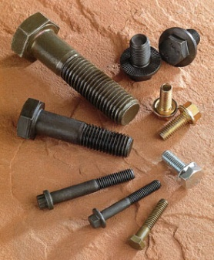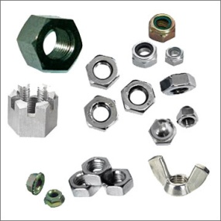

Nuts (castle, flared, wing and regular) Bolts

Some bolts and nuts use washers to keep them together. Lock washers come in different styles, but they all work by increasing the friction between a bolt and the nut/threaded surface. Machine screws come in many different thread configurations, shapes and sizes. These fasteners are generally used in holes that are threaded, in thin metal, or in light strength areas. Their heads are often designed for installation and removal with a screwdriver and not a hexagonal wrench.

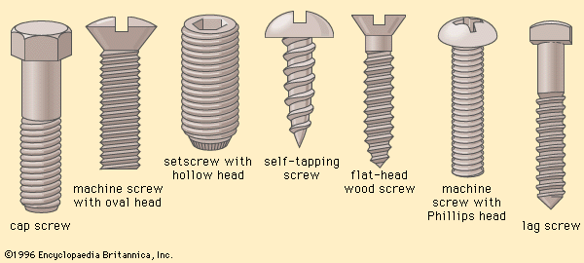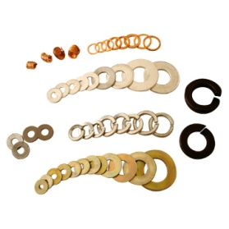

Washers ( copper, flat and lock) Machine screws

Pins are unthreaded fasteners which are installed in smooth holes in materials, usually shafts. They could be classed as regular cotter pins which are bent around the shaft to secure it, or hair type cotter pins which have a bent arm which hold it in place.

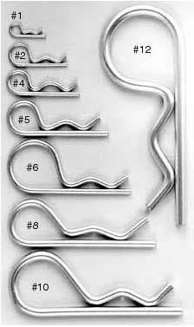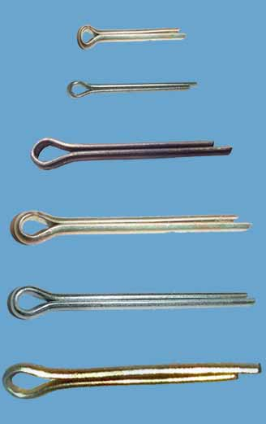

Regular cotter Pins Hair-type cotter pins

***Engine Identification***

There are several places to find identification information for a small engine. A series of numbers and letters is generally used to identify an engine for the purpose of ordering parts, finding out technical information, or assembly/disassembly information. This information is often stamped on the sheet metal engine shroud, on a tag or plate attached to the engine, or stamped into the engine block. It is not enough to take the information on an engine based on the equipment in which it is located. For example, a lawnmower made by Cousin Leroy’s Lawnmowers in Boharm, Saskatchewan may have used several different makes and models of engines over any given period of time. It is also possible that the engine currently being used in a piece of equipment may have been replaced at some point and no record made of the changes. That is why it is important to get the information directly off the engine itself.

Engine manufacturers will provide different identification specifications for their motors. They may have all – or some – of the following:

Model Number

Serial Number

Type

It is important to record this information and have it available when looking for technical information or ordering parts.

***Compression Testing***

Compression is necessary in an internal combustion engine in order for it to run. If the air/fuel mixture is not under compression, combustion will be incomplete and a maximum amount of energy/power will not be obtained from the power stroke.

SAFETY NOTE: Make sure the spark plug wire is disconnected from the engine and not touching the spark plug during the test. It is best to ground it to the engine by connecting it to the shroud or other metal part of the engine, away from the spark plug.

Testing for compression can be done several different ways. Simply turning the flywheel will allow you to feel if there is any resistance at some point during the revolution. However, if you aren’t turning the flywheel the same direction as the motor would turn when running, you will not have accurate results.

The best and most accurate way to test compression is to remove the sparkplug, insert a compression gauge in the spark plug hole and turn the motor over. Some compression testers actually thread into the spark plug hole, while others have a rubber adapter and the gauge must be held in the spark plug hole. The gauge will give a reading of the pressure within the cylinder and most gauges will hold the reading of the pressure until manually released.

There are different places in an engine which will allow for loss of compression. There is a gasket between the head and engine block and if it isn’t in proper condition, or if the bolts are not tight, leakage can occur. The piston is sealed by a series of rings which prevent gasses from passing the piston and entering the crank case. If these rings are worn or damaged, they may not seal the piston to the extent it needs. The final possible loss of compression can come from the valves. The intake and compression valves need to seat tightly in the valve seats or gases will pass past them.

***Spark Testing***

In order for an engine to run properly, it requires between 6000 and 10000 volts. Checking to see if there is spark in an engine is a basic form of trouble shooting.

Spark can be tested using commercially available spark testing equipment, or by using a new spark plug. Remove the plug wire from the spark plug and insert a new spark plug in the wire. Remove the old spark plug from the cylinder head and hold the new spark plug against the engine by grasping the rubber insulating boot on the plug wire. Turn the motor over by pulling the start cord or cranking the starter. There should be a bright blue spark jumping between the electrodes. If you do this test with the plug you took from the motor and there is no spark, then there is a good chance your plug is not functioning as it should. It is important

***Engine Disassembly Basics***

There are a few basic practices which make engine disassembly and reassembly easier. \*\*\*It is important to be prepared ahead of time and to make sure adequate time is left for clean up and work station closing when working on an engine.

Work Station Setup

Before you begin any work on your engine, complete an inventory sheet for your station. Have it checked by your instructor.

Make sure you are working on a surface which is not affected by oil, solvents, or contact from sharp metal edges. You should have something to remove excess oil from parts and your hands – such as paper towel – as well as something to protect your clothes from the same. If you use rags, make sure you have a safe container to store them in.

Ensure that there is some way to clean up any oil spills that may take place. One of the first steps will be to remove all liquids from the engine, so a place/container to store those fluids is also required. All oily rags or towels must be properly disposed of in a fire-safe container.

Have a container available to put your parts into. If you are working near another student doing the same operations, make sure you don’t get your parts mixed up.

Handy Hints

* When you begin to disassemble an engine, make sure you replace any bolts that you remove. This is important to avoid the “leftover bucket” issues that often accompany a motor job. Once a piece is removed and separated from an engine, re-insert the bolts in the correct holes. This is vitally important with some engines as the bolts which hold the head onto the engine block will often be of different lengths. Putting the wrong length bolt in the wrong hole may prevent the engine from operating properly.
* Wipe off any oil/grease from the parts before putting them in the storage container. Oily parts can attract dust and dirt which could cause other problems.
* Keep parts in units when possible. For example, don’t totally disassemble the carburetor and put it in the bin with other parts. Any multi-part component should be left intact and only disassembled when it can be reassembled in short order. It can be very difficult to remember where all small parts go and the order in which they must be assembled.
* Make sure you have a record of how the engine goes back together. This can be done by following instructions which include drawings or photographs, or by taking your own photographs as you disassemble the engine.
* Don’t try to “turn over” or “pull start” the engine without proper lubrication. A shot of spray lubricant is no match for proper oil.
* Righty tighty, lefty loosey. Simple, but important.

***Disassembly***

Determine the crankshaft orientation of engine. This is done by looking at the bolts which hold the engine to the equipment and by the orientation of the gas tank. Lawnmowers are generally vertical shaft and pumps, augers and ATVs are generally horizontal shaft.

Find all the information you can out about your engine. Locate the maker, model, type, serial number, location of manufacture, date of manufacture – everything you can about your engine. Use the internet and any other resources to find out as much as you can about your engine. Record this information in your workbook.

The following steps will require you to remove various parts from your engine. If after reading the directions you do not know what part you are being asked to remove, locate the part in the parts list for your engine and reverse look up the part in the diagrams. Where ever you see a check mark (🗸) beside an instruction, there is a corresponding instruction in your workbook. Have your instructor examine your progress and they will check and initialize your work at that point. Do not proceed until your work has been checked.

Remove the fan shroud/blower housing. This is the sheet metal covering that generally houses the starter rope/recoil. This shroud directs the air over the engine. The cylinder block of the engine is covered in fins which serve several purposes. They direct the air over the cylinder and they also create more surface area which allows the heat to radiate away from the block.

The flywheel has several purposes. The fins on the flywheel move the air which cools the motor. It draws the air in through the mesh screen and sends it outwards through the metal housing. The flywheel also houses the magnets which generate the electricity to fire the spark plug. Locate the magnets on the flywheel. Some engines that are electric start will also have gear teeth on the edge of the wheel as a place for the starter to engage and drive the engine. The weight of the flywheel also helps the motor to run smoothly by providing weight for kinetic energy. (🗸)

Next, remove the air cleaner. Take the metal cover off and examine the filter itself – commonly referred to as the element. Most small engines us a foam element which has been coated with a light oil. The oil acts as a trap for dust and dirt to keep it from entering the engine. Paper filters are more common on cars and trucks, but some oiled filters are used on heavy machinery. (🗸)

You should now be able to trace the fuel system of the engine. The gas tank will have a hose connecting it to the carburetor. The carburetor itself will have a series of linkages connecting it to the throttle cable and governor of the engine. Removing the air filter will allow you to look inside the carburetor and possibly see the internal parts. Locate the choke on your engine and manually operate it. Try to see how it restricts the airflow in the carburetor. (🗸)

Remove the gasoline from your engine by draining it into a container. Perform this operation outside to avoid getting gas on the floor. Be careful not to get any on yourself as the fumes will be with you until the affected clothes are washed. Keep the cap on the gas tank to help control any fumes that may remain. (🗸)

Remove the sparkplug from your engine. Make sure you use the correct socket. Spark plug sockets have a rubber insert which grasps the ceramic part of the plug and keep it from breaking or banging on any other parts.

Examine the plug for wear or any defects. When you put it in your parts bin, make sure it is not going to be damaged by any other parts. Wrap the electrode end in tape, or put it in a cardboard tube.

Remove the head bolts. Make sure you keep them in the right spot. It may be handy to make a heavy cardboard model of the head (cardboard in the shape of the head with corresponding holes) and stick the bolts in the corresponding hole. Carefully remove the head and the head gasket. Keep all undamaged gaskets in a large, brown envelope. Once the head is removed, you will be able to see the top of the piston and the two valves. Turn the flywheel by hand and observe the piston and valves moving. As you rotate the flywheel, trace the four strokes of the four-stroke cycle. It is a good idea to reattach the head to the block with the bolts being only finger tight. If you put them in loosely and the head gets dented or damaged, it may be difficult for it to ever get a proper seal again. (🗸)

Remove the flywheel. Depending on the make or model of engine, you might require special tools for this process. Research the process for your motor using service bulletins or repair manuals for your particular engine. This information can be found online (YouTube - repair clinic flywheel removal) or in the course materials made available to you. (🗸)

Trace the path of the electricity in your engine. Depending on the specific engine being used, there may be very few parts available. Late model electronic ignitions have few to no moving parts. Older model engines will have points, condensers, springs, a plunger, and others parts. Determine what the electrical components of your engine are and what they do for your ignition. Locate the on/off switch of your engine. This may be part of a safety switch if your engine has a flywheel lock. (🗸)

***Carburetion***

The carburetor is one of the most complicated – and important - components of any engine. The job it does is simple: mix the fuel with air. The way it does it is also pretty simple.

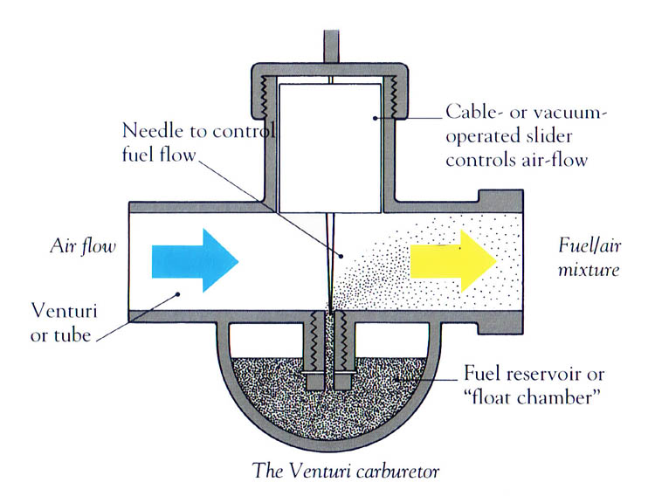

As air is drawn across an opening which has a liquid at the bottom (gas), it draws it through the opening and it mixes with the air. In the case of a carburetor, the air is drawn as a result of the vacuum created when the piston moves down on the intake stroke. It sucks the air through the air filter and past a tube which has gas at the bottom. The gas mixes with air and presto – there is your explosive mixture. However, there are many more things happening in the carburetor. There has to be control of the amount of fuel entering the airstream – generally done with a needle valve – as well as the amount of fuel entering the chamber. The following diagram gives a rough idea as to what some of the things are doing inside the carburetor.

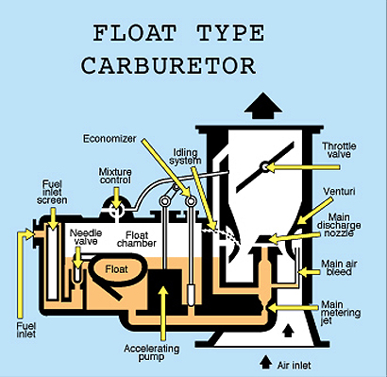

Your carburetor is attached to the block by bolts or screws, as well as by linkages and a fuel hose. First, detach the fuel hose, making sure that any fuel that may be in the hose is caught in a tray or absorbent material. Undo the screws/bolts and carefully separate the carb from the linkages. There may be springs and wires making up the linkage and it is important to note the way everything goes together and where it connects. The linkages will hook it to the throttle and the mechanical governor. (🗸)

Carefully empty any gas from inside your carb. Look in either end of the carburetor and try to see the various ports, valves and butterfly valves. Open and close the choke valve to see how tight it actually closes. When the choke is closed is restricts the air flow and increases the fuel being drawn into the cylinder. The idea behind this is to create a fuel-rich environment for the engine and give a better opportunity for starting.

***Mechanical Governor***

While some people think that a governor on an engine is to prevent over-speeding, the real purpose in the small engine field is to maintain a desired speed regardless of load. With a fixed throttle position, the engine could speed up if the load was lightened; if the load is increased the engine would slow down or even stop. A governor on the other hand will close the throttle if the load is lightened or open the throttle to obtain more power if the load is increased.

The pneumatic governor below is operated by the force of the air from the flywheel fins. When the engine is running the air from the fins pushes against the air vane. The air vane is connected to the carburetor throttle by means of a link. The force and movement of these parts tends, to close the carburetor and thus slow down the engine speed. Opposed to this is the governor spring which tends to pull the opposite way, opening the throttle. This spring is usually connected to an adjustable control of some kind so that the tension on the spring can be changed at the will of the operator. Increasing the tension of the spring will increase the engine speed. Decreasing the tension will lower the engine speed. The point at which the pull of the spring equals the force of the air vane is called the "governed speed"

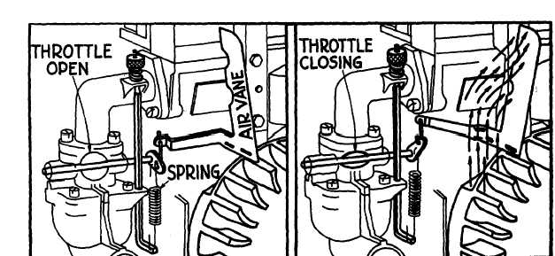

The mechanical governor shown below works in a similar manner except that instead of the force of the air blowing against the vane, we have the centrifugal force of flyball weights opposing the governor spring. In either case, operation is the same. As the load on the engine increases, the engine will start to slow down. As soon as this happens, the centrifugal force of the flyball weights lessens. This allows the governor spring to pull the throttle open wider increasing the horsepower to compensate for the increased load and thus maintain the desired governed speed. If the load on the engine lessens, the engine starts to speed up. This will increase the pressure of the centrifugal force and the spring will be stretched a little farther thus closing the throttle and reducing the engine power. A properly functioning governor will maintain this desired governed speed within fairly close limits.

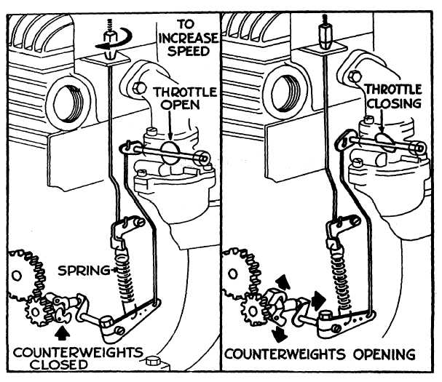

***Exhaust System***

The exhaust system is very simple on a small engine. It consists of the exhaust valve and the muffler. Carefully remove the muffler by loosening the bolts/screws holding it to the block, or in some case by loosening the star-type lock washer holding the muffler to the block. If the engine you are working on has been run for any period of time, it may have significant rust on the muffler. This is due to the oxidation associated with the process of burning gasoline. (🗸)

***Lubrication System***

Remove the oil from the engine by draining it into an appropriate container. If the oil is clean, it can be reused, so make sure you use a clean container with a lid. Your engine may have a filler extension which allows for easy checking and adding of oil. These can be attached with a screw or bolt, or just be held in place by friction in the oil fill hole. Remove this and make sure oil isn’t dripping from it. (🗸)

Turn the engine up-side down and begin removing the crank case bolts. Do not remove the bolts entirely from the engine – once they are loose, leave them in the hole. Again, they may be of different lengths and need to be kept in the right position.

Before you can take the cover off of the crank case, you need to make sure the end of the crankshaft is clean and doesn’t have any burrs or damage. Any sharp edges or ridges on the crankshaft will damage the seal when the crank case cover is removed. These sharp edges are best removed using a piece of emery cloth. Put a bit of lubricant on the crank shaft when you lift it off to allow for easy removal. (🗸)

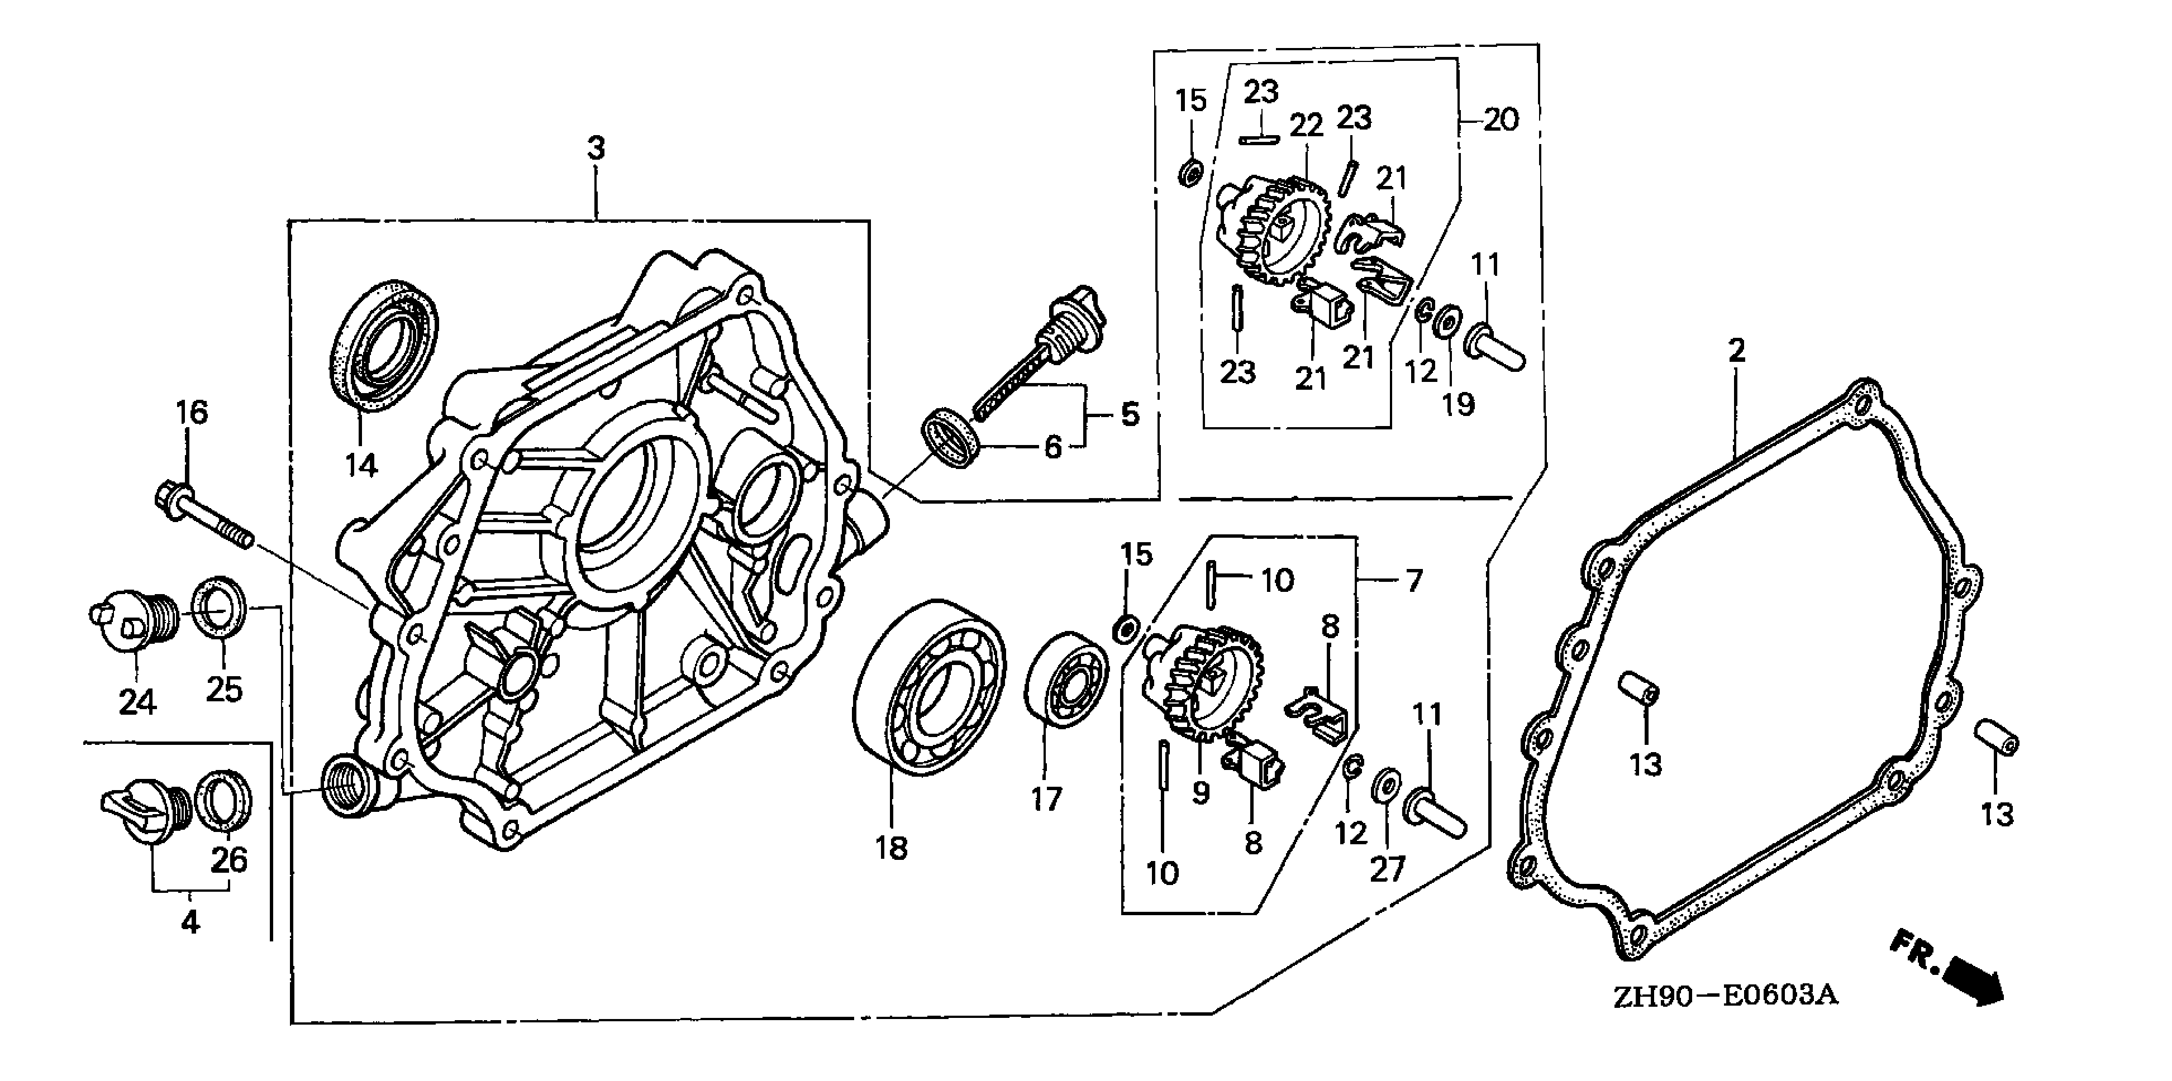

In the above diagram, part number 14 is the seal. It is a rubber skirt inside a metal ring with a spring around the central hole, keeping it tight on the shaft. This engine also has a bearing (18) which would support the crankshaft. This diagram also shows two different types of mechanical governors (group 7 and group 20)

***Crankcase***

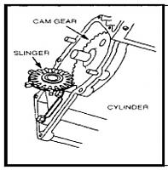There is a lot going on in the crank case. The crank shaft runs through it – one end was attached to the flywheel and the other would be attached to a blade or pulley for doing work. Your engine should be set up so the crank is pointed straight up. Beside the crankshaft is a large gear which meshes into a gear on the crankshaft. This large gear is the cam gear of the cam shaft. There is a chance that there is a nylon and metal geared device sitting on the gear – this is the mechanical governor. It will sit in a low spot on the crank case cover called the oil sump. This is where oil will run to during operation and the slinger splashes the oil around the inside of the crank case. Lift the slinger off of the gear and wipe down. The gear on the crank shaft which drives the cam shaft may also be removable. Before you remove it or the camshaft, locate the timing marks on the two gears. The cam shaft must be timed with the crank shaft to ensure the valves are opening and closing in careful coordination with the location of the piston. When the engine is re assembled, it is important to make sure the timing marks line up properly. (🗸)

When you lift the cam shaft out, you will see the lobes – or cams – on the shaft. These cams are what lifts and lowers the valves. They are connected to the valves through the lifters, which may also be removed at this time. The diagram below shows both a geared (1) cam shaft and a chain driven (2) cam shaft. The lifters look like small inverted valves (6), but the large end rides on the cams. The valves themselves (5 &4) were viewed earlier when the head was removed.

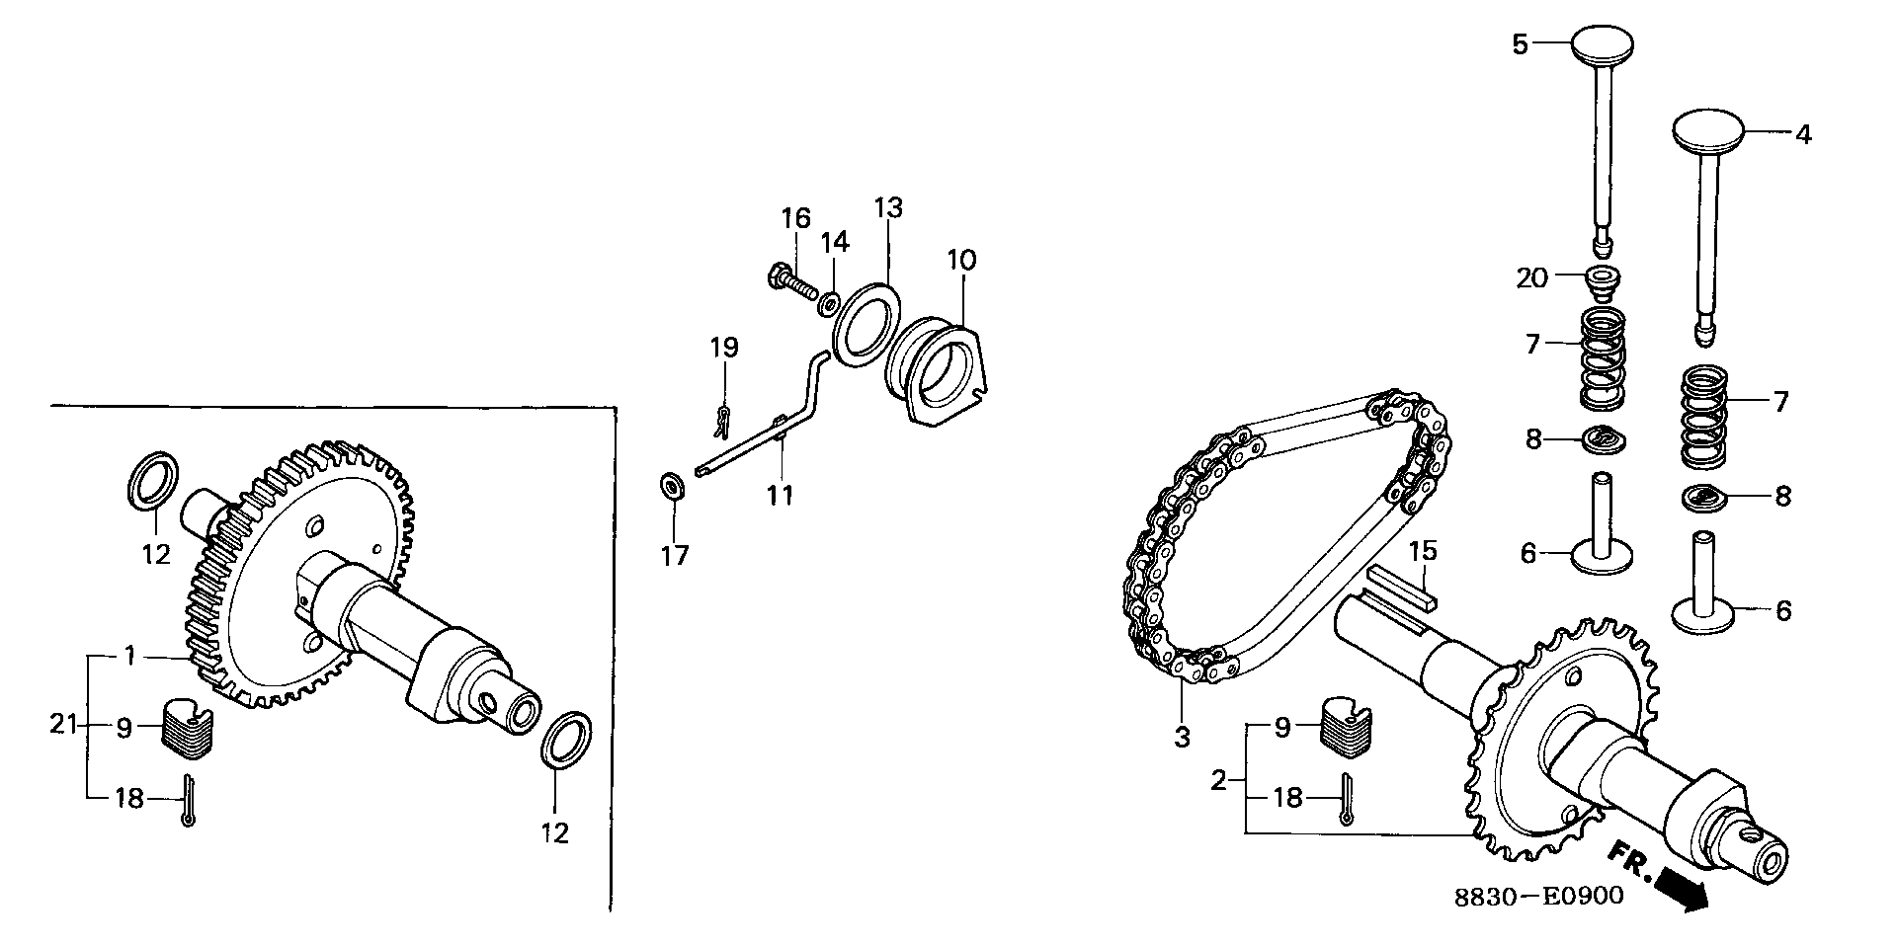

***Valves***

The valves will come out after the valve springs are removed. To remove the springs, remove the valve spring cover, keeping the gaskets in the correct order. Replace the screws in the block to avoid losing them. (🗸)

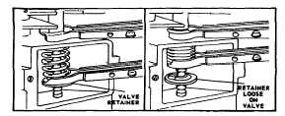The valve springs must be compressed before they can be removed. There are a couple of different types of spring retainers which may be used on your engine. The most common is a key-hole type retainer, with the two-piece retainer being an older design. To remove valves using retainers, slip the upper jaw of the spring compressor over the top of the valve chamber and lower jaw between spring and retainer. Compress spring, remove retainer and pull out the valve. Remove the valve spring compressor and spring. Make sure you keep the retainers with the spring and valve that they were originally with. (🗸)Once you have both valves out, compare them. In some engine designs, the valves are of different sizes and designs to allow for differing flow rates and gas movement. The springs, too, are often different. Because the exhaust valve is exposed to such high temperatures, they can lose some of their tempering and as a result, some of their “springiness”. By making the exhaust spring larger, they compensate for the possible loss of spring. (🗸)

***Piston Removal***

The piston is the heart of any engine. Care must be taken to keep all bearing surfaces and the inside of the cylinder from getting scratched or damaged in any way.

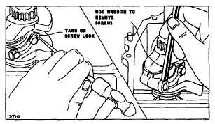The first step is removing the connecting rod cap from the connecting rod. The cap is held in place with cap screws and those are locked in place with a locking tab. The locking tab is loosened by taping the bent portion flat using a screwdriver, or punch, and hammer. Once the tab is removed, the screws can be removed using a box end wrench or socket. When removing the connecting rod cap, be very careful not to damage the bearing surface. (🗸)

The piston may now be removed by pushing it through the top of the engine. If the engine has been run, there will be a carbon ring around the top of the cylinder indicating the upper most position of the piston. This ring must be removed using a ridge remover before the piston can be removed. Once the ridge is removed, the piston can be pushed through. (🗸)

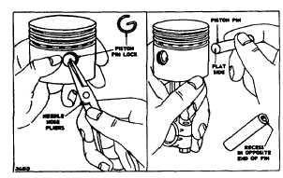The connecting rod cap should be reattached to the connecting rod to prevent any accidental damage to the bearing surfaces. The cap orientation is directed by notches or markings which allow it to fit together only one way. DO NOT FORCE THE CAP. Attach the cap finger tight.

The wrist pin can now be removed. The pin is held in with retainers that are removed using needle nose pliers. Remove one retainer and push the pin out. Re-insert the retainer to avoid losing it. Once the pin is out, the connecting rod can be removed. (🗸)

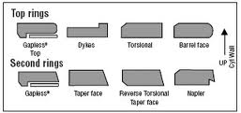Every piston has a series of rings. Once your piston is removed an in your hand, you will see the grooves cut in the side of the piston and the rings that are held in the grooves. These rings do different jobs and different engines will have different numbers of rings. Regardless of the number, the rings do the same thing. The top ring will be a compression ring to ensure gasses don’t pass the piston and get into the crankcase. The second ring is generally a scraper ring to remove excess oil from the cylinder wall during combustion. The bottom ring is designed to allow oil to pass through it and distribute it around the cylinder wall. (🗸)

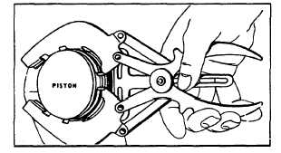Ring removal requires a special tool called a ring remover. There are different styles and types, but the most common is a pliers type device which gently spreads the rings apart just enough to lift them off the piston. Spreading them too much will cause them to snap and new rings must be put in. before removing rings it is important to note which ring design is in which groove. (🗸)

***Crankshaft***

The crankshaft should now slip out of the block. There is a chance that there are bearings attached to the crank at some point. These are generally pressed on using a hydraulic press, but they should be left in place unless they are visibly damaged. Locate the positions where the shaft passes through the block and crank case cover and find the seals. Closely examine them and determine how they work. (🗸)

***Measuring Bearing Clearance of Connecting Rod***

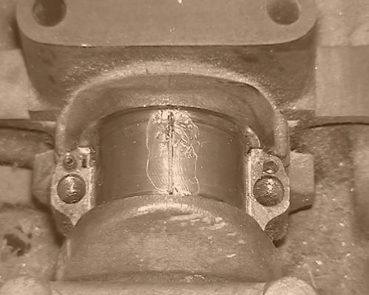Before you reassemble the engine, you are going to measure the clearance between the connecting rod and the crankshaft. To do this, you will require the appropriate torque wrench and socket and torque specification for your engine as well as a piece of “Plastigage”. Clean the bearing surfaces of the crank and the connecting rod. Place a piece of the wax thread on the crank shaft, but do not discard the wrapper.

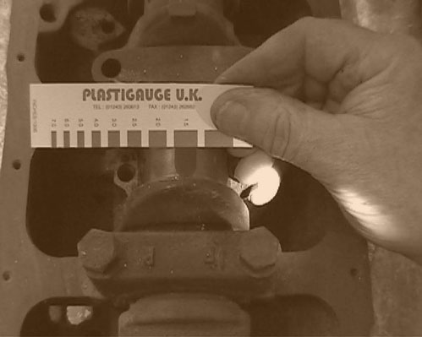Next, place the connecting rod cap on the connecting rod, insert the bolts and tighten them to the correct torque. ***Make sure the rod doesn’t turn on the crank during this operation***. Once the cap screws are tightened, remove them and compare the width of the now flattened wax thread with the gauge included on the Plastigage wrapper.

The line that corresponds to the width of the squished wax has a measurement associated with it. This is the clearance between the crankshaft and connecting rod. Your specification sheet will have tolerances which will allow for the re-use of the connecting rod, or the replacement of it. If the gap is too big, there will be undesired movement on the crankshaft and the result will be uneven wear, power loss and shortened lifespan of the parts involved. This process can be used between any two metal parts that are directly connected. It won’t work where there is a gasket as the gasket itself will absorb some of the pressure and not allow for an accurate reading.

The formula for determining a measurement from Plastigage is shown below. That is why it is okay to just read the measurement from the package. Figuring this out could give you a headache.

Formula_1.gif

***Engine Reassembly***

Not surprisingly, engine reassembly is pretty much doing things in the reverse order from disassembly. There are, however, some steps that need to be taken to ensure a properly functioning engine.

* Dry installation – all metal surfaces which contact each other during assembly must be coated with motor oil. It is easily applied by dipping a finger in oil and rubbing it on the surfaces, or by using a small oil soaked rag to wipe the parts down. All seals need oil as well to avoid tearing from friction.
* Torque – most of the bolts on an engine are installed with a certain amount of torque. Check your manual or service bulletin to determine the correct amount of torque for each bolt.
* Ring Assembly – the rings go on in the reverse order, but it is important that the gaps do not line up. Spin the rings so they are about 120° - 1/3 – apart.
* Piston Installation – a special tool called a ring compressor is used to squeeze the rings on the piston and allow for the piston to be pushed into the cylinder. It is vitally important that the piston and cylinder walls get a layer of motor oil to avoid scoring. Once the piston rings are compressed, push the bottom of the piston into the cylinder and then use the handle end of a hammer to tap the piston down into the cylinder. The connecting rod and crank shaft will only go together one way. If the connecting rod is facing the wrong way, it will hit the side of the crank case when turned. Install the cap finger tight and try turning the crank. If it turns correctly, tighten the cap screws. If the engine is a working piece and will be run, there is a series of measurements that can be taken to determine if the piston needs to be replaced. Consult your manual or specification sheet for this information.
* Cam Shaft – make sure the timing marks are lined up on the camshaft and the crank shaft.
* Gaskets – if a gasket was torn during disassembly, it should be replaced. A tip to hold gaskets in place when putting an engine together is to put a very thin film of oil on one surface, place the gasket, then replace the mating surface and tighten. If a gasket does not appear to be damaged, replace it after wiping off any dirt or debris. If the engine you are working on is a demonstration engine and will not be run, slightly damaged gaskets may be reused.
* Linkages – connect the linkages to between the carb and the governor before bolting the carb to the block or attaching the fuel line.

***Occupational Connection Worksheet***

Watch the video clips “Motorcycle Mechanics” and “Automotive Mechanics”.

Complete an Occupational Connection Sheet for this module. The purpose of the worksheet is to develop an understanding of how the activities undertaken in this module may be connected to an occupation. Your research may come from several sources. A speaker may come to your class to talk about mechanics in the role of their occupation. You may choose to research the Alberta Learning Information Service ([www.alis.alberta.ca](http://www.alis.alberta.ca)) or any other Canadian information service. The role mechanics takes in the occupation may be direct and obvious, or it may be indirect or just a small component of. When you finish your Occupational Connection Worksheet, go over it with your instructor and have them initial the appropriate space in worksheet 3. (🗸)